

Parents’
Preschool Manual

NORTHVIEW CHRISTIAN CHURCH
SONSHINE
623 N State Road 39, Danville, IN 46122
(317) 745-2566
www.northviewchristian.org

Welcome to Preschool!

Thank you for choosing our program for your child’s preschool education. We are excited to partner with your family to build a solid foundation for your child. Our staff loves Jesus as our Lord and Savior and wants your children to know and love Him, too! We strive for excellence through our teaching of Jesus and His Word, academics, and social and motor skills. Your child will be taught through song, stories, puppets, role playing, cooking, arts and crafts, play, and direct instruction. Let us know what we can do to make your experience successful.

You are welcome to visit the school and your child’s classroom at any time. We look forward to getting to know you and your family. My door is always open. Have fun this year and enjoy your child and all his/her experiences in preschool. As the year progresses, you will receive announcements of upcoming events and special days. If we can be of any assistance, do not hesitate to contact us. We hope you enjoy your experience at Sonshine!

In His Service,

Becky Tenaglia—Sonshine Director
becky@northviewchristian.org
Cell: (919) 730-2857 (before 9 pm)

Assistant Director
sonshine@northviewchristian.org
(317) 745-2566

Nathan Rector—Lead Pastor
nathan@northviewchristian.org
Cell: (509) 688-3988

Children’s Pastor
Randy Ferguson—Chairman of Board
rferguson100@comcast.net
Cell: (317) 610-6505

TABLE OF CONTENTS

OUR PHILOSOPHY.................................................................................. 3

OUR MISSION.......................................................................................... 3

GOALS FOR PRESCHOOL...................................................................... 3

ADMISSION PROCEDURES.................................................................... 4

CLASS SIZE RATIOS............................................................................... 4

SONSHINE SCHEDULE........................................................................... 5

WEATHER AND SCHOOL CLOSINGS.................................................... 5

EMERGENCY PROCEDURES................................................................. 5

FINANCIAL INFORMATION...................................................................... 6

CENTER CLEANING ROUTINES............................................................. 6

ITEMS FOR PARENTS TO PROVIDE...................................................... 7

ADDITIONAL INFANT/TODDLER INFORMATION................................... 7

ARRIVAL AND DEPARTURE PROCEDURES......................................... 8

TOILET TRAINING.................................................................................... 8

NAPS......................................................................................................... 8

MEALS....................................................................................................... 9

COMMUNICATION AND RESOLVING FAMILY CONCERNS.................. 9

CHILD CUSTODY…………………………………………………….…..…… 9

DISCIPLINE AND BEHAVIOR MANAGEMENT POLICY........................ 10

SERIOUS INCIDENT POLICIES AND PROCEDURES........................... 11

ABUSE AND NEGLECT REPORTING..................................................... 11

PARENT INVOLVEMENT......................................................................... 12

HEALTH, IMMUNIZATIONS, AND ILLNESSES....................................... 13

SONSHINE MEDICATION ADMINISTRATION POLICY.......................... 16

SAFE SLEEP POLICY.............................................................................. 19

OUR PHILOSOPHY

Children are a precious gift from God. The preschool program is based on the philosophy that children are fearfully and wonderfully made by God (Psalm 139:14) and created in His image (Genesis 1:26). Just as clay is molded by the potter’s hand, our children need to be molded according to God’s specific purpose (Jeremiah 29:11).

Our precious ones will have a safe, loving environment to learn through the teaching of God’s word. Our children will see God’s love through the tender loving care of our staff as we meet each child’s needs to grow to his/her fullest potential.

The Sonshine program is based on the assumption that children pass through stages of development and learn at their own rate. The teacher’s responsibility is to guide the balance of creative fun, hands-on play, and cognitive learning. The teachers will work with parents to oversee each child’s physical, emotional, social, spiritual, and academic growth.

We believe that parents and grandparents are the primary and most important providers of care and nurturing. We plan to be partners with them for each child’s care and education.

OUR MISSION

Sonshine, a ministry of Northview Christian Church, desires to provide a foundation of biblical truth and academic excellence that prepares children for a successful start of school, and the knowledge that they are loved by God and our staff.

GOALS FOR PRESCHOOL

Our curriculum and care are designed to nurture, encourage and support the skills needed to develop the whole child. The staff will provide experiences to develop skills in the following areas: language, number concepts, fine and gross motor skills, self-help, social awareness, problem solving, and listening. Within all these skills we desire to instill a love for God and compassion for others. Our program addresses the following goals:
- To provide opportunities that develop social skills enabling interaction with peers and with adults in a positive manner.
- To help each child grow emotionally by instilling a positive self-image; by helping the child accept change by recognizing and expressing feelings of joy, anger, sadness, and frustration in an acceptable manner.
- To offer experiences to develop physically through indoor and outdoor activities that promote large and small muscle development and motor control.
- To encourage the development of skills necessary for logical thinking and decision making.

ADMISSION PROCEDURES

- Children between the ages of 6 weeks and five years are accepted to the Sonshine. Afterschool and summer camp are also available for school age children through 3rd grade. Enrollment may be made at any time during the year if there is space available.
- You may schedule a tour and talk with the director to ask questions and determine availability. An enrollment form may be obtained from the director or the website.
- We encourage parents to bring their child for a visit in the classroom before their initial start date.
- Required forms must be completed and turned in to the director before the child’s first day of school. These forms include:
- Enrollment Form and New Student Fee
- All About My Child
- Media/Photography consent and Release Form
- General Field Trip Permission
- Birth Certificate
- Immunization Record (keep updated when new shots given)
- Physical Exam Form (within the first 30 days of enrollment and annually for 2 years of age and younger)
- Record of Medication Order (if applicable)
- Copy of IFSP or IEP (if applicable)

In addition, for Infant/Toddlers:
- Feeding Plan, children under 13 months of age
- Safe Sleep Policy, children under 13 months of age
- Breast Milk Agreement (if applicable)

- A waiting list will be maintained when classrooms are full.

CLASS SIZE RATIOS

As per Indiana Child Care Center Licensing each class has a maximum class size according to square footage of available space per room (infants 50 sq ft; todds-4’s 35 sq ft per child) and child/staff ratio. The child/staff ratio for each room is as follows:

Infants 4:1 max 8:2 (sq ft max 8)
Toddlers 5:1 10:2 (sq ft max 10)
2’s 5:1 10:2 (sq ft max 10)
2 ½ 7:1 14:2 (sq ft max 12)
30-36 month
3’s 10:1 20:2 (sq ft max 13)
4’s 12:1 24:2 (sq ft max 13)
PK 12:1 24:2 (sq ft max 18)
ASC 15:1 30:2

SONSHINE SCHEDULE

Sonshine is open Monday through Friday from 7:00 a.m. to 5:30 p.m. year- round. Summer camp for school age children begins Tuesday after Memorial Day. Sonshine will be closed on the following dates:

Teacher Workday August 6, 2021
Labor Day September 6, 2021
Thanksgiving November 24-26, 2021
Christmas Holiday December 24-31, 2021 (not charged 5 days)
New Year’s Day January 3, 2022
Good Friday April 15, 2022
Memorial Day May 30, 2022
Fourth of July July 4, 2022

Parents will be charged for these days (except for Christmas Holiday).
Other dates to remember:

Grandparents Day September 10, 2021
Fall Festival October 29, 2021
Thanksgiving Feast November 23, 2021
Happy Birthday, Jesus! December 16, 2021
Winter Games January 28, 2022
Valentines Class Party February 14, 2022
Teddy Bear Picnic PJ Day February 25, 2022
Literacy Month March—activities all month
Green Eggs and Ham March 2, 2022
Father’s Breakfast April 22, 2022
Teacher Appreciation May 2-5, 2022
Mother’s Luncheon May 6, 2022
PK Graduation May 17, 2022
Summer Camp begins May 31, 2022 (provided snow days are not needed)

WEATHER AND SCHOOL CLOSINGS

We will make every attempt to be open as scheduled. However, there will be times Sonshine must close due to inclement weather or another emergency. Closings will be posted on Sonshine Facebook page and MomentPath. If Sonshine must close during the day, we will text through MomentPath and/or the telephone numbers you have provided to attempt to notify parents.

EMERGENCY PROCEDURES

Monthly fire drills and evacuations, as well as tornado drills and lock downs, will be practiced so children know what to do in an emergency. In an actual emergency, we will make every effort to contact you, using the telephone numbers you have provided.

FINANCIAL INFORMATION

- Application Fee. A non-refundable application fee of $100 per child is charged on all new applications.
- Tuition. Tuition rates are reviewed each year. Our goal is to have quality of care, stay competitive, and consider staff salaries/benefits when determining our tuition rates. Families will receive a month’s notice, in writing, of fee adjustments. Infants $227 weekly, $54 daily; Toddlers $210 weekly, $48 daily; 2’s $200 weekly, $46 daily; 3’s $190 weekly, $44; 3-4’s $182 weekly, $42 daily; PK $182 weekly, $42 daily; After School Care (ASC) $60 weekly, $16 daily; School Age Summer all day $155 weekly, $40 daily.
- Discount. There is a 5% discount available on monthly payments when paid by the 5th of the month for families who attend at least 3 days a week (a minimum of 12 days a month). If not paid by the 5th the discount will be removed.
- Sibling Discount. There is a 5% discount available on siblings.
- Vacation Rate. Full time (5 day/week) year-round students have the option of one week of vacation at ½ tuition rate upon request.
- Payment. Payments are due the morning of the child’s first day each week by cash, check or money order. Payment is due even when a child is absent. Payment is due for days Sonshine is closed except for a week at Christmas and closings due to snow days and/or emergencies. Returned check fee of $25 will be charged per check returned.
- Late Pick-up Fee. There is a charge of $1 per minute after 5:30 p.m. you are late picking up your child. We will bill your account for this fee.
- Absences. Days missed due to illness, vacations, trips, etc. cannot be credited for fee reduction. All fees for all children must be paid whether your child is in attendance or not.
- Summer Camp. Your school age child may participate in our summer camp, offered between school year sessions. More information can be obtained from the office.
- Tax ID Number. For tax purposes, our tax identification number is #351170691. Please keep all statements if you anticipate using childcare as a tax deduction or if your business requires the information for a childcare benefit.
- Withdrawal. Parents may withdraw their child from enrollment in preschool upon giving a two (2) week written notice or paying two (2) weeks tuition.

CENTER CLEANING ROUTINES

Daily: Sanitize toys, tables, counters (teachers)
Sweep floor and carpet, sinks, toilets, doorknobs (teachers and custodial staff)

Weekly: Sanitize cots —more frequently, if needed (teachers)

Other: Toys cleaned when rotated out for other toys (teachers)
Nursery carpet cleaned every 6 months (custodial staff)

ITEMS FOR PARENTS TO PROVIDE

- Change of clothing. Because of toilet accidents, food spilled, water or mud from the playground, etc. Provide a complete, labeled change of clothing, including underwear and socks. These clothes will be kept in your child’s individual container for emergency use. Be aware of changes in weather and replace the clothes accordingly.
For Infants/Toddlers and 2’s: Please provide at least two changes of clothes, including socks.
- Nap items. Your child needs to feel comfortable during naptime with their sleep items. Parents supply a child-sized blanket and may supply a small pillow and soft toy for sleeping. Every Friday, parents should take the nap items home to wash them.
For Infants/Toddlers: Sonshine provides crib sheets which will be changed daily. No blanket, sleep toys or pillows will be in the crib while sleeping.
- Girls must wear shorts under their dresses.
- Shoes. For safety, children should wear closed toe shoes. Shoes must have at least a heel strap.
For Infants/Toddlers: As your child begins to walk please provide shoes for
stability and safety.
- Weather gear and sunscreen. Dress your child appropriately for the weather of the day. Provide cold weather clothing and rain covers. Our children typically are outside every day, except for extreme weather. For hot sunny days, parents may provide sunscreen lotion (NO AEROSOL CANS) for the teachers to administer in the afternoon. Parents should first apply sunscreen at home before arriving.

ADDITIONAL INFANT/TODDLER INFORMATION

- Parents provide an unopened package of diapers and wipes. You will be notified when these items need to be replenished through Momentpath.
- Bottles and any food that you bring must be fully prepared at home—labeled with child’s name, date prepared, and ounces in the bottle. Bottles will be kept in the refrigerator. Bottles will be heated by a bottle warmer.
- Bottles AND bottle tops, sippy cups and/or food containers must all be labeled with the child’s name, what’s in the container, and the current date.
- As your infant begins eating regular food, they can eat school food. Talk with the teacher to update your infant’s feeding plan.
- Our nursery is a shoeless environment. When you enter the room, please remove your shoes or use provided shoe covers before coming on the carpet.
- On arrival, communicate with the teacher when your child had his/her last bottle, last diaper change, and when your child woke up in the morning.
- On departure, gather all bottles, food, and dirty clothes used for the day. Teachers will provide your child’s activities throughout the day through Momentpath.

ARRIVAL AND DEPARTURE PROCEDURES

- Traffic. Enter and exit through the north driveway. Enter the building through the north door. For the safety of the children, please do not drive around the back of the building.
- Sign in. Please park, walk your child to the teacher in charge, give the teacher any significant details for the day, and the teacher will sign in your child on Momentpath.
- Late or no arrivals. If arriving after 9:00 am, enter the room quietly as not to disrupt teaching. If your child will not be at school, please contact the office and let the school know he/she will not be there at (317) 745-2566.
School age: If your child will not be getting off the bus at Sonshine as scheduled, please call the office to let the school know he/she will not be there.
- Pick up. An adult (18 years or older) who is listed on your application as authorized to pick up your child may pick him/her up. Parents may add to that list, in writing, any adult 18 years or older. We may ask the adult picking up your child for identification if he/she is not known to the staff. No child will be released to anyone suspected of being under the influence of drugs or alcohol.
- Check cubby or Sonshine bag. When picking up your child, check his/her cubby or Sonshine bag daily. Take home soiled clothes from accidents and any work your child may have done during the day. Clean out cubby out or take bag on Fridays, including blankets, etc. to clean and bring back Monday.
- Sign out. Please sign out your child by making contact with the teacher in charge. The school day ends at 5:30 pm. If you are late, two staff members will remain until you arrive, you will be billed $1 per minute. A courtesy call or message at (317) 745-2566 to let us know you will be late is appreciated.
- Toys. Leave personal toys at home unless it is a sleep toy. Unless the teacher communicates there will be show and tell. We do not allow water guns, toy guns, toy weapons or any kind of play fighting.

TOILET TRAINING

Sonshine staff fully supports “potty training” when the child and their family is ready for this important transition. If your child is “potty training”, we do ask that you bring your child to school in regular underwear—not pull ups or diapers. However, diapers may be worn at naptimes. We will remind a child hourly to take a bathroom break, encouraging a long period of time with the comfort of dry underwear. If, and when, the underwear does get wet, the child will be uncomfortable and will learn more quickly about taking control. Parents should provide plenty of changes of clothes for the first steps in this process. Help us to help you by keeping the same routine at home, as much as possible.

NAPS

Licensing guidelines require a rest time for all children. Your child needs to feel comfortable during naptime with their sleep items. Children must lie down quietly and rest even if they do not sleep. There is music playing, books read then rest. Non-sleepers can read and play quietly on their cot. A cot is provided for each child and sanitized each Friday or as needed.

MEALS

- Meals and Menu. Breakfast (7:30-8:00), morning and afternoon snack, and lunch (11:00-11:30) are provided for your child at no extra charge. A monthly menu is posted in Momentpath.
- Milk. Vit D and 1% Milk will be provided for each child. Parents may provide other nutritional substitutes if desired.
- Food Brought from Home. Any food brought from home or purchased for your child must fit nutritional guidelines. This includes breakfast in morning, snacks, lunch and special event foods. A Safe Transportation of Food Responsibility form must be complete and returned to the office whenever food is brought from home for an individual child.
- Allergies. Because peanut butter is a major allergy in young children there are no peanuts or peanut butter in any form in the preschool area or around our preschool children. Children with food allergies must have a Food Allergy Action Plan and Safe Transportation of Food Responsibility form completed and signed by the child’s health care provider and returned to the office.
- Choking hazard to children under three (3) years of age, including, but not limited to, the following:

Whole grapes
Hot dog rounds
Hard candy
Nuts
Seeds
Raw peas
Dried fruit
Pretzel nuggets
Chips
Popcorn
Marshmallows

Chunks of meat larger than children can swallow whole

COMMUNICATION AND RESOLVING FAMILY CONCERNS

Your teacher will communicate with you verbally and/or through messages on Momentpath, weekly teacher newsletters, incident report on tend.ly, notes home and administration communications. Parents may have questions about events, actions, or policies. We ask the parent to first address their concern with the teacher. The teacher will very likely have a quick answer for your question. If not, she may direct you to the director. If your question or concern remain, contact the Pastor of Northview Christian Church.

CHILD CUSTODY

Legal decisions regarding issues of child custody will be respected. We have to assume that both parents have the right to pick up their child, unless we are given a copy of a court order stating otherwise. Without a copy of the court order, Sonshine cannot refuse a parent. If we have a court order and a non-custodial parent tries to pick up the child, we will immediately call the custodial parent. We will not place the other children at risk in a confrontation with the non-custodial parent.

DISCIPLINE AND BEHAVIOR MANAGEMENT POLICY

We believe that children are a gift from God and that they should be treated tenderly, not crushing the spirit but helping to shape the will. Praise and positive reinforcement are effective methods of the behavior management of children. When children receive positive understanding interactions from adults, they develop good self concepts, problem-solving abilities, and self-discipline. Based on this belief of how they learn and develop values, this center will practice the following rules:

 | WE |  | WE
1. | DO praise, reward and encourage the children. | 1. | DO NOT spank, shake, bite, pinch, pull or slap the children.
2. | DO explain things to the children on their levels. | 2. | DO NOT shame or punish the children when bathroom accidents occur.
3. | DO model appropriate Christian behavior for the children. | 3. | DO NOT relate discipline to eating, resting, or sleeping.
4. | DO listen to the children. | 4. | DO NOT deny food or rest as punishment
5. | DO provide alternatives for inappropriate behavior to the children | 5. | DO NOT leave the children alone, unattended, or without supervision.
6. | DO provide the children with natural and logical consequences of their behavior. | 6. | DO NOT place the children in locked rooms, closets, or boxes as punishment.
7. | DO treat the children as people and respect their needs, desires, and feelings. | 7. | DO NOT allow discipline of children by children.
8. | DO modify the classroom environment to attempt to prevent problems before they occur. | 8. | DO NOT criticize, make fun, or otherwise belittle children’s parents, families, or ethnic groups.
9. | DO reason with and set limits for the children. | 9. | DO NOT make fun of, yell at, threaten, make sarcastic remarks about, use profanity, or otherwise verbally abuse the children.
10. | DO stay consistent in our behavior management program.
Time out: Time outs will not be used at Sonshine in the form of “sitting in a hair” in accordance with state licensing regulations.

TV USE

The use of TV is very limited to age appropriate and with educational value for the purpose of curriculum or end of day. Children are giving alternative choices as well.

10
SERIOUS INCIDENT POLICIES AND PROCEDURES

When serious incidents occur:
The teacher in charge is responsible:
- to notify the director as soon as a serious incident has occurred under their supervision
- to document on Momentpath with accuracy the details of the incident
The director is responsible:
- to following up with the parents of all the children involved in the incident
- to document in writing their understanding of the incident
- to report the incident to the Indiana Department of Child Services

What is a serious incident?
- an emergency where 911 is called
- a major head injury
- an incident involving a large amount of blood

Teachers should notify parents when a minor injury occurs, or a disciplinary action was taken for a repeated inappropriate behavior.

What are some examples of a minor injury or inappropriate behavior?
- head injury
- injury involving blood
- biting
- hurting self or another child in anger

Response by staff to inappropriate behavior
- Care is given to the child that was bitten first—wash area and apply ice pack.
- Redirect the child who bit and talk about being kind not hurting our friends.
- Re-evaluate our program for specific strategies and techniques to address biting.

Repeated inappropriate behavior procedures: Repeated behaviors (such as hurting self or another child in anger, disrespect to teachers, biting another person) will be managed according to these steps:
- The teacher will verbally and in writing communicate with parents.
- The director will verbally and in writing communicate with the parents.
- The center and parents will seek help from Child Care Answers (information about Child Care Answers can be obtained through the director).

ABUSE AND NEGLECT REPORTING
We are required by law to report to Child Protective Services if we suspect any abuse or neglect.

11

PARENT INVOLVEMENT

Parents are invited to visit and observe the center at any time. Teachers will meet with individual parents to review each child’s progress throughout the year. Conferences may be scheduled at any time. Annual conferences will be scheduled for Infants and Toddlers as they transition to the next classroom. All others will be scheduled in April. Parents of our infant, toddler and 2’s children receive daily written through Momentpath and/or verbal information regarding their child. If parents have concerns or need assistance with problems related to the center, they may discuss the issue, if applicable, with the staff involved. If they are not satisfied, they may discuss their concerns with the director or with the Pastor.

Social and educational events are held throughout the year to encourage interactions between staff and families. These events include but are not limited to the following: Grandparents Day, Father’s Breakfast, Mother’s Luncheon, Thanksgiving Celebration, Green Eggs and Ham, Fire Truck. Parents may plan and help prepare parties, share their culture and jobs, eat lunch with your child, play with the children on the playground, and provide other similar activities.

Field Trips
Children 4 years old-ASC going on a field trip will be transported by staff or parent transportation. In the event of a field trip, a special permission form must be signed by parents before we can take your child off campus for each field trip. Sonshine uses unlicensed space—infants and toddlers stroller ride in church hallway and on sidewalk around the building; 2’s-ASC outside fenced area and grassy areas for large group or water activities—and will ask parents to sign a form that indicates parent’s knowledge that their child is participating in activities in unlicensed space.

Birthdays and Celebrations
Parents may provide special treats for your child’s class to celebrate their special occasion. The goods provided by parents must be in the original store-bought unopened packaging. Due to food allergens we cannot serve homemade items to the children. Please no peanut butter. Check in advance with the teacher about any special allergy conditions a child in the class may have.

Donations
Toys, books, clean underwear, shirts and pants no longer in use at home will be welcome additions to our preschool supplies.

Special Needs
All the children Sonshine serves in our program deserve special attention. The goal of our program is to serve all children to the best of our ability. When children come with identified special needs, we will seek resources to better equip our staff to provide the necessary care for each child.

12

HEALTH, IMMUNIZATIONS, AND ILLNESSES

- Physical exam. Licensing regulates that all parents provide a medical report, signed by a physician, within the first 30 days of attendance. Children 2 years and younger will need to provide an annual physical exam. It must include a current immunization record.
- Communicable Disease Exposure: Parents will receive notification of any communicable disease to which their child has been exposed. Likewise, all parents are responsible to notify Sonshine if their child has a communicable disease. (See Chart at the end of this section pages 14-15 for complete list of Communicable Diseases.) The child must stay at home for at least the time indicated below:
- Strep Throat and Scarlett Fever (24 hours from initiation of medicine)
- Staph Infection (24 hrs from initiation of antibiotic and wounds covered)
- Conjunctivitis (Pink Eye) (24 hours after initiation of treatment, and no further drainage)
- Lice (after successful treatment, with no remaining evidence of live lice or nits)
- COVID-19 (3 days with no fever, respiratory symptoms have improved, and 10 days since symptoms first appeared). This would apply to staff and children in the center. If a member of the family, in your home, has tested positive, your child should quarantine for 14 days from the day when the family member had a fever or symptoms.
- Symptoms. If the staff observes symptoms of illness in your child during the day care hours, you will be called to take your child home. Keep your child home if he/she has symptoms of:

- Fever (100 degrees or more) If your child has had a fever, you must keep him/her home at least 24 hours after the fever has gone
- Nausea or vomiting (child can return 24 hours after last occurring symptom
- Diarrhea (child can return 24 hours after last occurring symptom)
- Swollen glands
- Acute cold
- Hand, Foot and Mouth (child can return 24 hours after being fever free and blisters are scabbed over and no new blisters)
- Skin rash or bumps
- Inflammation of eyes (return 24 hours after initiation of treatment)

- First Aid. All Sonshine staff is certified in first aid. Several staff are always CPR certified with at least one present. If a child is injured on school grounds and the injury is minor, it will be washed, and a Band-Aid applied if necessary.
- Outside play. If a child is well enough to come to school, he/she must join the others in outside play.
- Accidents and Medical Emergencies. If accidents occur at school, a parent will be notified by a phone call. If a serious accident or other medical emergency occurs, your child will be taken to the nearest hospital by ambulance. A preschool official will accompany the child if the parents are not present and will stay with the child until parents/guardians arrive. Every effort will be made to contact parents/guardians in the event of illness or accident.

13

- Medication. Sonshine staff cannot administer over the counter medicine, with possible individual exceptions approved by the director. Only the director (and designee in her absence) may offer prescription medication. Refer to Medication Administration Policy in this manual for specific instruction.
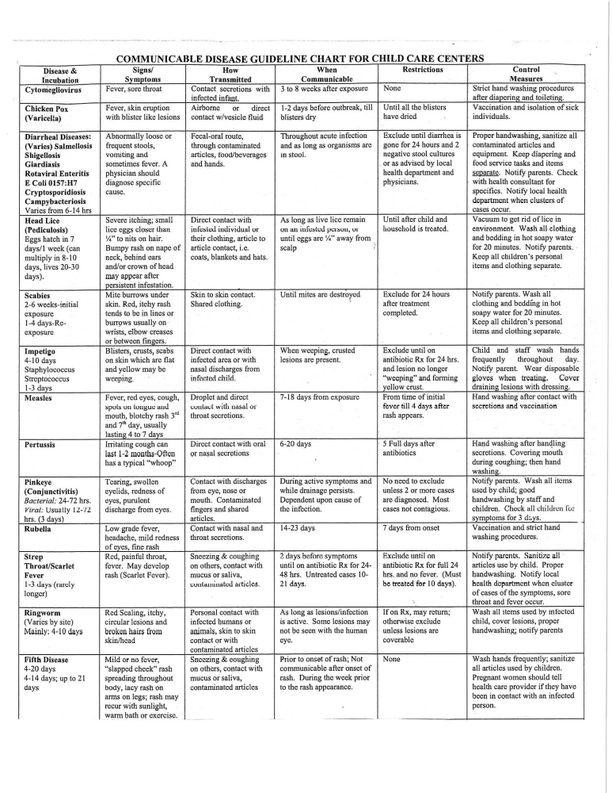
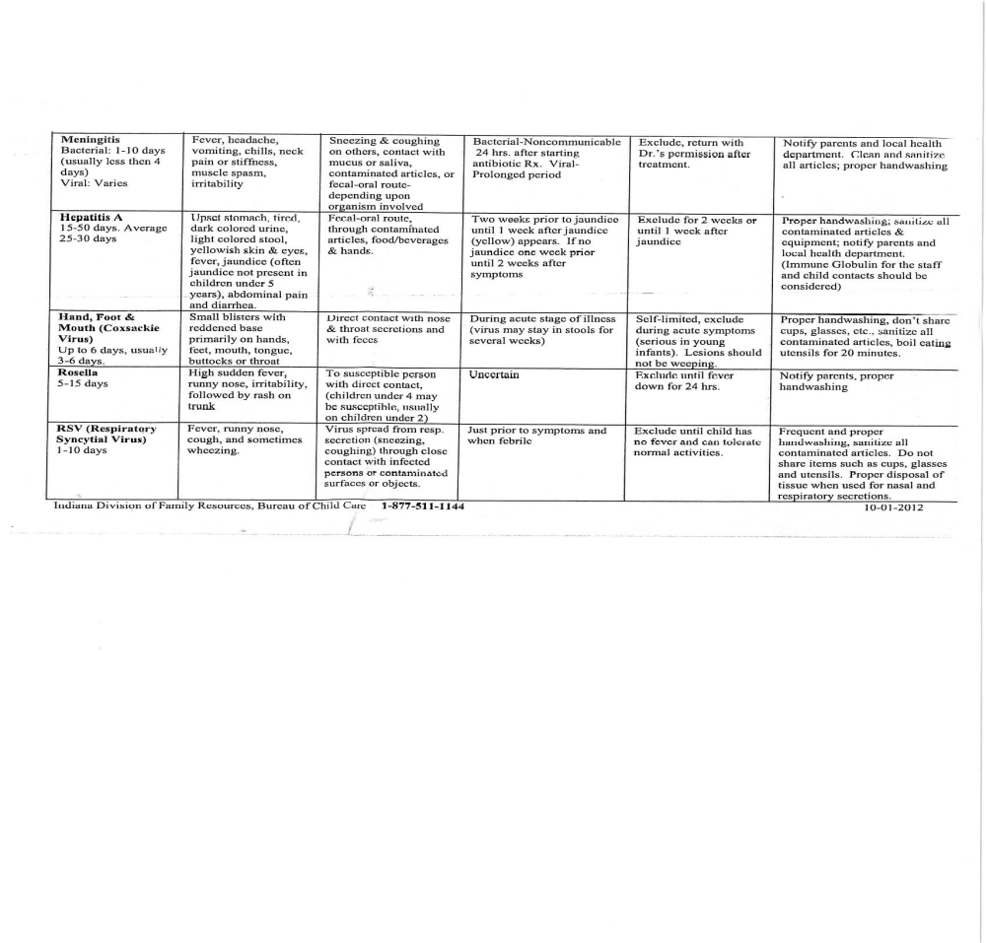

14

15

SONSHINE MEDICATION ADMINISTRATION POLICY

This policy is intended to ensure safe administration of medication to our children with chronic conditions, mild illnesses, or special health needs for whom a plan has been made and approved by the director. Because the administration of medication can pose a liability, it is necessary for Sonshine to have a policy in place.

Administration of Medication requires clear, accurate instruction and knowledge of why a child needs the medicine. Childcare providers need to be aware of what the child is receiving, when it is to be given, how to read the label directions in relation to the measured doses, frequency, expiration dates, and be aware of any side effects. This policy applies to all medication administration for any child within the facility.

This policy is consistent with Department of Child Development rules but may be more restrictive.

I. Written Authorization:
- Medication will be administered only if there is a physician’s written permission and the parent or legal guardian has provided written, signed, and dated consent to include:
  - child’s first and last name
  - name of medication
  - time the medication should be given and how often
  - criteria for the administration of the medication
  - how much medication to give
  - the way the medication shall be administered (oral, topical, injection, etc)
  - medical conditions or possible allergic reactions
  - length of time the authorization is valid, if less than six months
- The length of time the consent is valid:
  - Up to six months:
    - A prescription medication shall be valid for the length of time the medication is prescribed to be taken, up to six months.
    - Prescription or over the counter medication, when needed, for chronic medical conditions and for allergic reactions.
  - Up to 12 months:
    - To apply over the counter, topical ointments, gels, lotions, or creams such as sunscreen, diapering creams, or insect repellant to a child, when needed.
- A physician’s note must accompany any medication.
- Exception to Authorization: A caregiver may administer medication to a child without parental authorization in the event of an emergency medical condition when the child’s parent/guardian is unavailable. The medication must be administered with the authorization and in accordance with instructions from a bona fide medical care provider.

II. Prescription Medication
Prescription medications such as antibiotics, seizure medications or others:
- Must be administered only to the child for whom they were prescribed.
16
- Must be in its original child-resistant container labeled by a pharmacist to include:
  - child’s first and last name
  - name of medication
  - date prescription was filled
  - name of health professional who wrote the prescription
  - medication expiration date, storage information
  - instructions on administration: dosage amount, frequency, and specific indications for “as needed”.
As needed medications: A physician may state that a certain medication may be given for a recurring problem, an emergency, or chronic condition. The instructions should include the above information in II.2. For example, a child may have sunscreen applied as needed to prevent sunburn; a child who wheezes with vigorous exercise may take one dose of asthma medicine before large muscle play; a child with a serious allergic reaction may develop symptoms needing immediate attention (e.g., EpiPen)

III. Over the Counter Medications
Over the Counter (OTC) medications such as cough syrup, decongestant, acetaminophen, ibuprofen, topical antibiotic cream for abrasions, or medication for intestinal disorders:
- Must be in the original container labeled by the parent or legal guardian with the child’s first and last names.
- Must be accompanied by written instructions signed and dated by a physician and the parent or guardian specifying:
  - child’s first and last name
  - name of the medication
  - conditions for use
  - dose of the medication
  - how often the medication may be given
  - length of time the authorization is valid
- Administered as authorized with specific, written instructions by the parent or legal guardian not to exceed amounts and frequency of dosage specified by the manufacturer.
- If manufacturer’s instructions include consultation with a physician for dose or administration instructions, written dosage instructions from a licensed physician or authorized health professional is required.

IV. Medications will not be given if it is:
- not in the original container
- beyond the date of expiration on the container
- without written authorization
- beyond expiration of the parental or guardian consent
- without the written instructions provided by the physician or other health professional legally authorized to prescribe medication
- in any manner not authorized by the child’s parent/guardian and physician or other health professional
- for non-medical reasons, such as to induce sleep

17
V. Receipt, Storage and Disposal:
- All medications brought into the center will be given to the director for review and approval.
- Medications will be stored in a sturdy, child-resistant, locked cabinet that is inaccessible to children and prevents spillage.
- Medications will be stored at the temperature recommended for that type of medication. It shall not be stored above food. A lock box to hold medications can be kept in a designated refrigerator not accessible to children.
- Emergency medication may be left unlocked so long as they are stored out of the reach of children at least 5 feet above the floor.
- Non-prescription diaper creams shall be stored out of reach of children at least 5 feet above the floor but are not required to be in locked storage.
- Any medication remaining after the course of treatment is completed or authorization is withdrawn will be returned to the parent/guardian within 72 hours or it will be discarded. Dispose of liquids in their containers with cap on tight and placed in dumpster. If disposing needles give to the parent/guardian to properly dispose. Contact your Health Department if there are any questions of proper disposal of medications.

VI. Training:
- Only staff persons who have documentation of medication administration training by a licensed health care professional will administer medication.
- A staff member trained in medication administration will be on site at all times when children are present.

VII. Documentation:
- A medication log will be maintained in the child’s file by the facility staff to record any time prescription or over-the-counter medication is administered by childcare facility personnel.
- The child’s name, date, time, amount and type of medication given, and the name and signature of the person administering the medication shall be recorded for each administration.
- The log may be part of the medication permission slip or on a separate form developed by the provider which includes the required information.
- Only one medication shall be listed on each form.
- Spills, reactions, and refusal to take medication will be noted on this log.
- No documentation shall be required when over the counter, topical ointments, gels, lotions, and creams—such as sunscreen, diapering creams, or insect repellents—are applied to children.

VIII. Medication Error:
- In the event of a medication error, the appropriate first aid or emergency action will be taken.
- Director, parent/guardian, and as needed, the nurse or physician will be notified.
- A medication error and an incident report will be prepared.

This policy applies to all staff, families, volunteers, and visitors who use the childcare services at Sonshine.
18
Northview Christian Church Sonshine
Infant/Toddler Safe Sleep Policy
(required for under 13 months of age)
Date Adopted: June 30, 2019

Sudden Infant Death Syndrome (SIDS) is the unexpected death of a seemingly healthy baby for whom no cause of death can be determined based on an autopsy, an investigation of the place where the baby died and a review of the baby’s medical history.
The Child Care Law requires that childcare providers caring for children 12 months of age or younger implement a safe sleep policy, share this information with parents, and participate in training.
Sonshine believes providing infants with a safe environment in which to grow and learn is extremely important. Also, all families have a right to safe and healthy childcare and will practice the following:

- Infants less than 12 months of age shall be placed on their backs on a firm tight-fitting mattress for sleep in a crib to lower the risks of Sudden Infant Death Syndrome (SIDS).
- All pillows, blankets, quilts, comforters, sheepskins, stuffed toys, and other soft products will be removed from the crib.
- The infant’s head will remain uncovered at all times including during sleep.
- When infants can easily turn over from the supine to prone position, they will be put down to sleep on their back but allowed to adopt whatever position they prefer for sleep.
- Positioning devices that restricts movement within the child’s crib shall not be used.
- There is no smoking allowed in the childcare setting.
- Infants will not share a crib with other children.
- Supervised “tummy time” will be observed while infant is awake.
- All staff counted in ratio in the Infant room will receive training on safe sleep practices before caring for infants annually.

This policy will be reviewed with the parents at the time of application and a copy will be provided in the parent handbook.
SIDS information will be published annually in the Parent Manual and available as a handout. This policy will be reviewed during annual training and new staff orientation. A copy will also be provided in the staff handbook.
Parents and staff will be notified of any upcoming policy review.

19

